Name:

How are you doing?

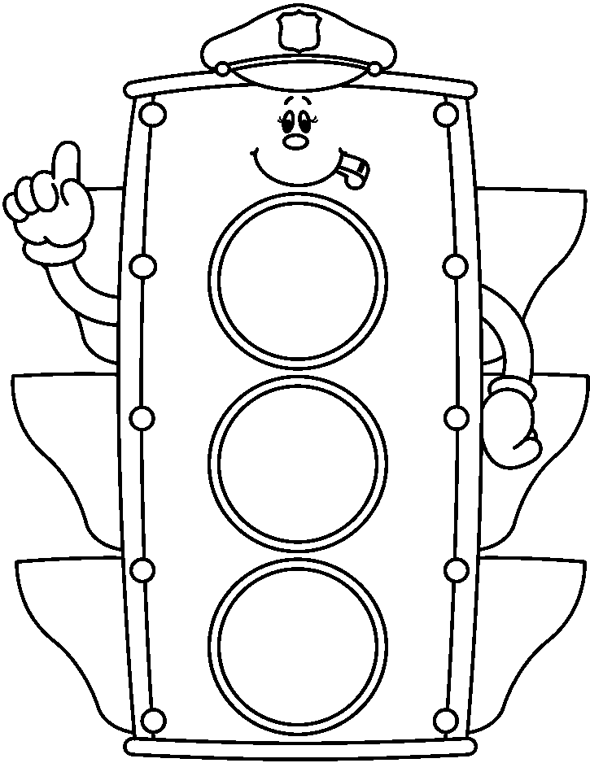

Color the yellow stoplight if it is starting to make sense

Color the green stoplight if you know   
how to make an inference

Color the red stoplight if you need some more practice.