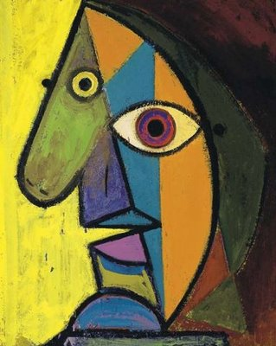

Pictures
Of
Picasso
Kristen ter Steege
Grade 3 Art
January 4th – January 29th, 2016
Ecole Agnes Davidson School

Throughout this unit students will have the opportunity to learn about the artist Picasso as well as the methods he used throughout his career as an artist. Students will have the opportunity to create their own Picasso art in a variety of methods using a variety of mediums. Students will explore and implement Picasso’s techniques to complete 3 projects in total. The first project will be a “warm-up” that asks the students to use shapes to draw a face of their choosing. Students will color this picture with different colors that express mood. The second project will be a mixture of drawing and collage art; students will be asked to draw the shape of the head (their choosing) and then fill in the aspects of a face using magazine clippings that express different emotions. The final two classes will require the students to create a self portrait using the techniques they have learnt throughout the unit as well as students will be asked to use oil pastels to remind them to use bright, contrasting and mood provoking colors.
Overview

Rationale

Throughout this unit, students will have the opportunity to appreciate and interact with art in a meaningful way. Students will learn about the artist themselves to gain a wider appreciation for the creativity of Picasso and how they to can implement different techniques to create their own personal art. Students will have the opportunity to express their feelings through Picasso art, as Picasso art is dedicated to expressing multiple points of view and emotions through perspectives and colors. Students will be able to respond to visual forms in nature, and artworks. Students will be able to develop imagery based on observations in the visual world. Finally, students will use art materials as a vehicle or medium for expressing their feelings in a meaningful way while considering different perspectives.
Objectives

Component 3: APPRECIATION: Students will interpret artworks by examining their context and less visible characteristics.
Concepts:
- Contextual information (biographical) may be needed to understand works of art
- Artistic style is largely the product of an age
- Our association influence the way we experience a work of art
- Art is valued for different reasons
Component 4: DEPICTION – Students will perfect forms and develop more realistic treatments
Concepts:
- Shapes can suggest movement or stability
- Many shapes are symmetrical
- Internal as well as external proportions can be depicted.
Component 6: QUALITIES AND DETAILS – Students will refine surface qualities of objects and forms.
Concepts:
B. Color can be made to appear dull or bright
Component 9: CRAFTMANSHIP: Students will improve compositions by refining, rehearsing and critiquing
Concepts:
B. Rehearsals and ongoing critiques should be scheduled to improve composing skills.
A. Feelings and moods can be interpreted visually

Timeline
Class | Outline | Outcomes
Tuesday January 5th, 2016 | Introduction to Picasso: history, techniques, short book, warm up sheet | Component 3:  - Contextual information (biographical) may be needed to understand works of art  - Artistic style is largely the product of an age  - Our association influence the way we experience a work of art  - Art is valued for different reasons
Tuesday January 12th, 2016 | Collage Picasso (magazines and paper) | Component 9:  B. Rehearsals and ongoing critiques should be scheduled to improve composing skills.  A. Feelings and moods can be interpreted visually
Tuesday January 19th, 2016 | Oil Pastels – self portrait (final project) | Component 3, 4, 6 & 9 (see above)
Tuesday January 26th, 2016 | Oil Pastels – self portrait (final project) continued | Component 3, 4, 6 & 9 (see above)
Materials and Resources
Lesson Planning Resources:

You Tube Videos:
http://www.mykidsart.com.au/Pablo_Picasso_Famous_Artists_My_Kids_Art.html
https://www.youtube.com/watch?v=RlNf5XZDcQs

Websites:
http://en.paperblog.com/explore-art-picasso-portrait-project-78535/
http://dadaenfantterrible.blogspot.ca/2013/08/art-face.html

Other:
Picasso Face Roll and Draw Sheets (Sponge Activity if needed)

Materials:

Paper
Oil Pastels
Magazines
Construction Paper
Pencils
Pencil Crayons

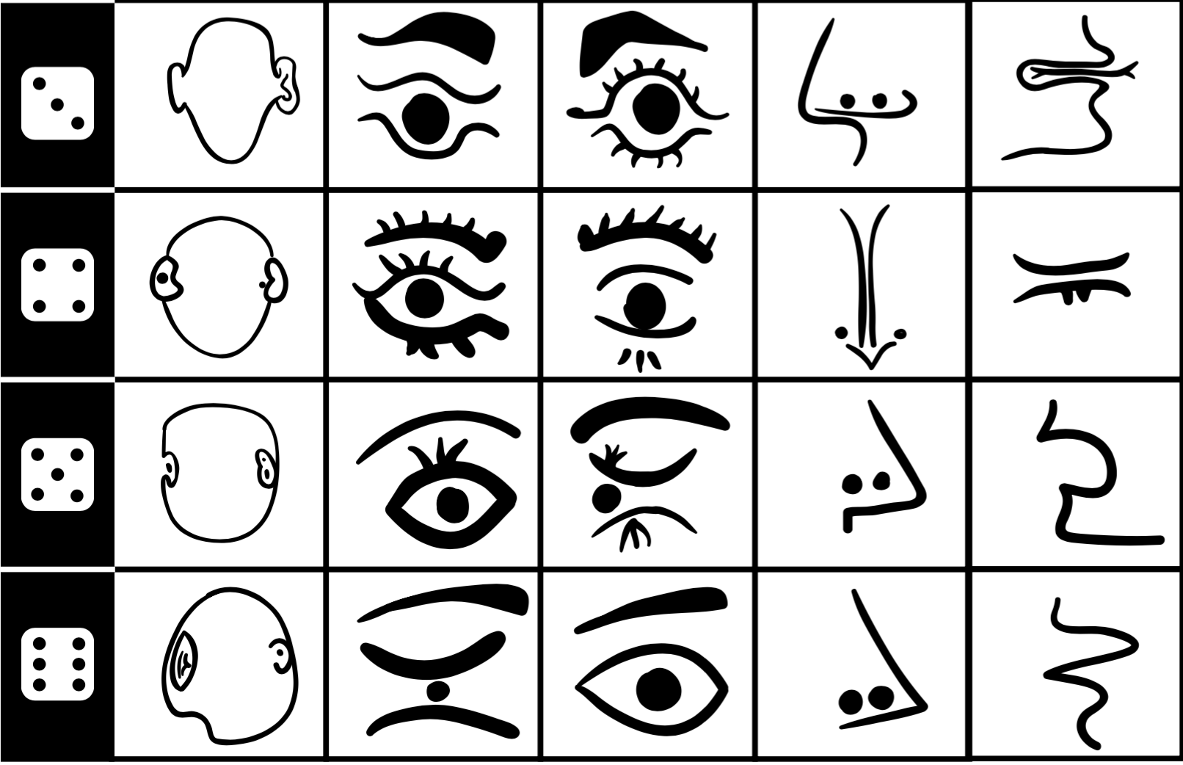
Books:

Lives of the Artists – Kathleen Kull
Paris in the Spring with Picasso – Joan Yolleck
Just Behave, Pablo Picasso! – Jonah Winter
In the Time of Picasso – Antony Mason
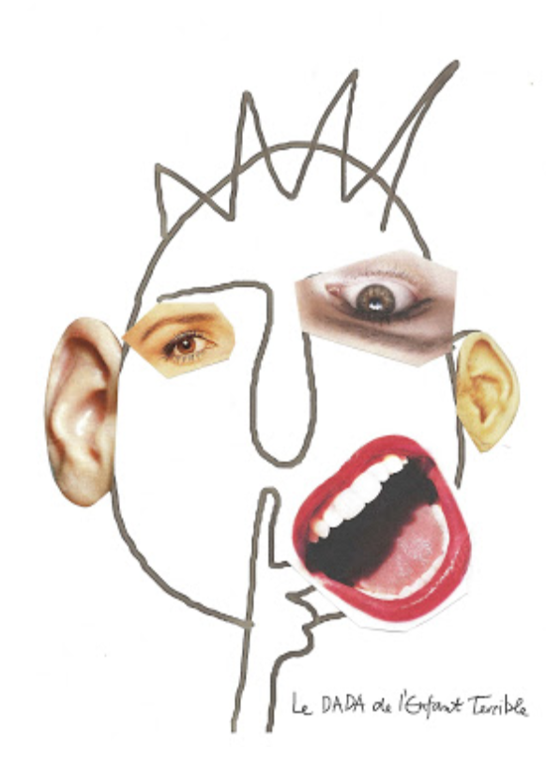
A Day with Picasso – Susanne Pfleger

