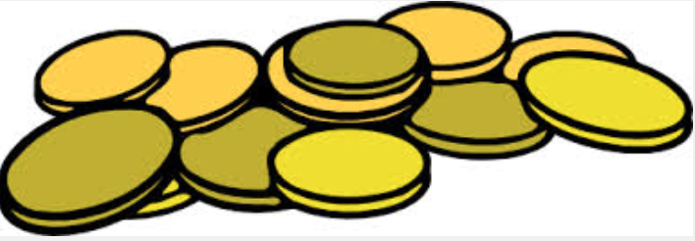
Fairy Tale

Each coin=1 point

Student’s Name: Grade:

How many coins did you earn?

4- Wow! 3- Yay, I got it! 2- Almost got it! 1- Needs some work

Content:

My writing has a sense of time and place, like “Once upon a time”

I have good characters and evil characters.

I have a problem in my fairy tale.

I have a solution to the problem in the story.

I have a beginning, middle and ending.

I used some words or phrases that are used in fairy tales.

I completed the writing process.

My final narrative writing shows illustrations that go with the story.

My Total Points (Coins)

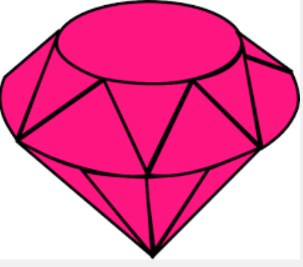

20-24 coins equals a ruby!
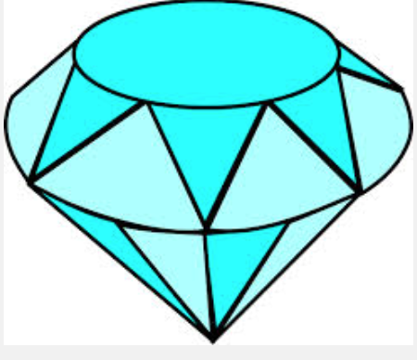
25-32 coins equals a ruby and a sapphire!

