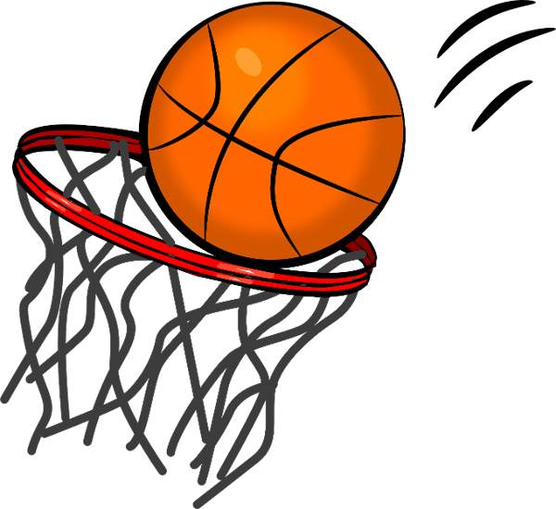
Basketball Superstars

Kristen ter Steege
Grade 3: Physical Education
Ecole Agnes Davidson School
January 5th – February 4th
Students will learn a variety of basketball skills over this 5-week unit. Students will refine skills they have learnt before as well as improve on skills that have been taught to them previously. Students will incorporate their skills throughout drills, games, and activity centers. Each week students will learn/review a new skill and incorporate the skill with the skill learned the previous week. Thus, students will learn a new skill and continually add new skills in order to refine and combine skills to become an overall better basketball player. Students will be asked to work in small groups, large class instruction as well as medium sized groups. Because it is a combined class of 50, each class will begin with a review of safety rules in the gym. Each lesson will begin with a warm-up (not basketball related) in order to increase student’s heart rates and prepare them to listen and cooperate. Each lesson will end with a cool-down to aid in transitions beyond the walls of the gymnasium.
Rationale
Overview

By participating in individual activities as well as team activities students learn the importance of cooperation and teamwork to achieve a goal, as well as the importance of each student possessing different abilities. Students will also learn important aspects such as coordination. An important aspect throughout this unit is safety, students will learn the importance of respecting others space as well as listening to instructions and commands in order to keep their classmates safe. Students will appreciate where they are at in their skills and learn to improve their own skills rather than compare themselves to others. Students will also learn the importance of practice as well as the combination of skills that create good sports and make the game play flow more smoothly. By introducing skills slowly and allow students to have an opportunity to refine before incorporating another skills, students will observe how physical activities are something that must be practiced and refined and do not come naturally to all people. Basketball is a great way to get students interacting with each other and their own bodies to improve to the best of their abilities while maintaining a safe environment where their peers can also practice and refine their skills.
Resources
- Basketballs Games
- Pinnies Safety Rules
- Drills
- http://www.learnnc.org/lp/media/lessons/womensacc/2010ACCcurriculumGuide-PEelementary.pdf

Students will be observed throughout the unit, teacher will keep notes of attitude, skills (does the student try their best), teamwork and cooperation in the gymnasium. Students will also be assessed on their safety practices and consideration of others.
Assessment Plan

Students will be given a grade out of 5 on the following aspects: skills, teamwork, cooperation, safety and attitude throughout. Students will have an opportunity to grade themselves and the teacher will consider this when making his/her final decision.
Objectives

General Outcome A: Acquire skills through a variety of developmentally appropriate movement activities; dance, games, types of gymnastics, individual activities and activities in an alternative environments; e.g. aquatics and outdoor pursuits

A3-5: Demonstrate ways to receive, retain and send an object, using a variety of body parts and implements; and, perform manipulative skills individually and with others while using a variety of pathways.

A3-7: Select and perform basic skills in a variety of environments and using various equipment.

A3-9: Select and perform simple movement sequences by using elements of body and space awareness and relationships, alone and with others.

A3-10: Perform and play lead-up games and demonstrate elements of space awareness, effort and relationship.

A3-11: Demonstrate the ability to work together with a teammate/team to achieve a common activity goal while playing and learning the basic strategies of lead up games.

General Outcome B: Understand, experience and appreciate the health benefits that result from physical activity.
B3-3: Experience movement involving the components of health-related fitness; e.g. flexibility, endurance, strength, cardio-respiratory activities

General Outcome C: Interact positively with others

C3-3: Identify and demonstrate etiquette and fair play

C3-4: Accept responsibility for assigned roles while participating in physical activity

C3-5: Display a willingness to share ideas, space and equipment when participating cooperatively with others

General Outcome D: Assume responsibility to lead an active way of life.

D3-1: Express a willingness to participate regularly in physical education class

D3-3: Demonstrate the ability to listen to directions, follow rules and routines, and stay on task while participating in physical activity

D3-4: Demonstrate and participate in safe warm-up and cool-down activities

D3-9: Make appropriate movement choices with consideration for safety of personal space, ability and surrounding environment.

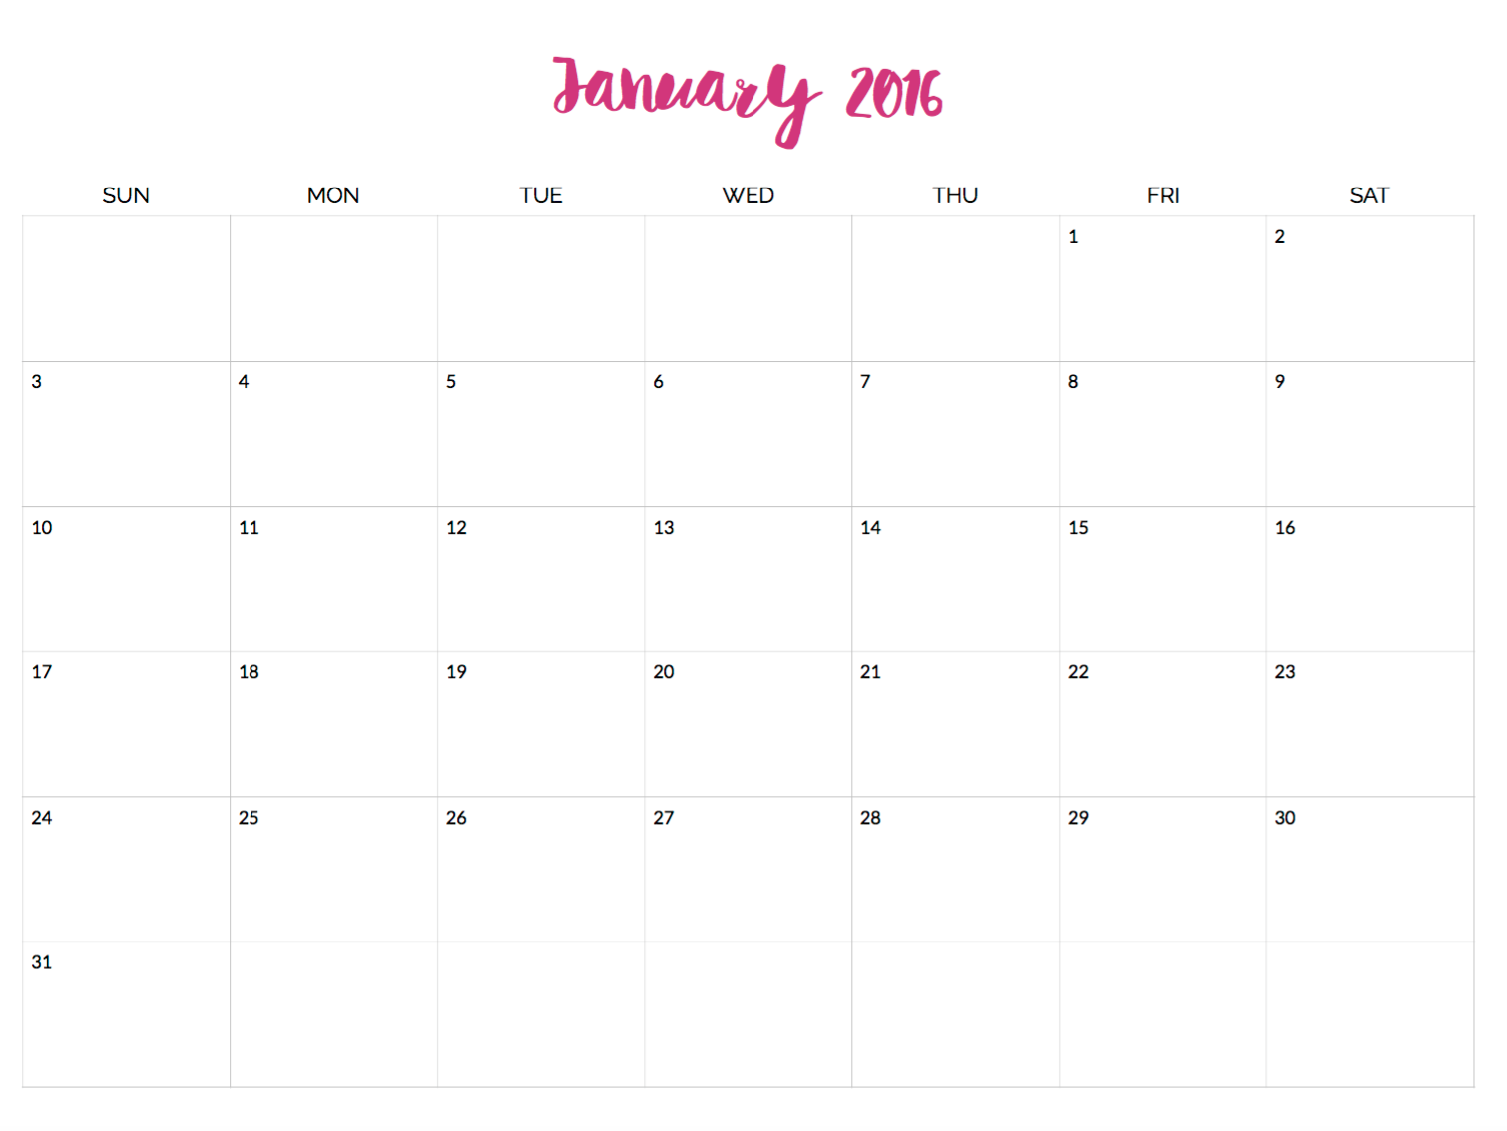
Introduction to Basketball:
Safety Rules
Cooperation
Skill #1: Dribbling
Practice & Drills

Dribbling Games
Skill #2:
Passing
Skill #2:
Passing
Drills
Skill #2:
Passing Games
Skill #3:
Shooting
Skill #3:
Shooting Drills
Skill #3:
Shooting Games
Combining Skills:
Dribbling and Passing
Combining Skills
Dribbling and Shooting
Combining Skills:
Dribbling, Passing
then shooting
Skill Centers
Skill Centers
GAME DAY

